Department Activity 2016-2017
S.No | Date | Name of the Activity
1 | 22-08-16 | Student seminar
2 | 23-08-16 | Quiz
3 | 01-09-16 | Quiz
4 | 30-09-16 | Guest Lecture
5 | 30-09-16 | Guest Lecture

S No | Date | ACTIVITY REPORT & PHOTO Activities 2019-2020
1 | 22-08-16 | Student seminar:Parimila,III B.A student presented student seminar on “public revenue”(pic1).T.Naga Jyothi presented presented student seminar on “Scope of public finance”(pic2).K.Malleswaramma presented student seminar on “Types of taxes”.(pic3)  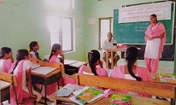  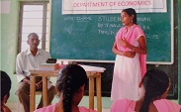  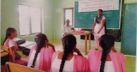
2 | 23-08-16 | Quiz: Quiz competition was conducted to II B.A students on “National Income”.  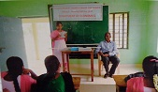
3 | 01-09-16 | Quiz: Quiz competition was conducted to III B.A students on 5 year plans.  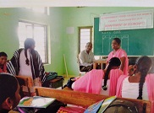
4 | 30-09-16 | Guest Lecture: M.Brahmaiah Lecturer in Economics V.R.S &Y.R.N college chirala delivered a Guest lecture on “Multipier to II B.A students.  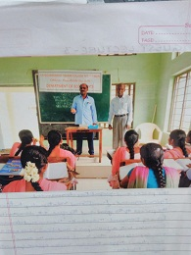
5 | 30-09-16 | Guest Lecture: k.Bhaskar RaoLecturer in Economics t.r.r govt degree college Adanki delivered a Guest lecture on “Law of demand to I B.A students.  